Project Design Phase-II
Technology Stack (Architecture & Stack)
Team ID
Project Name | Subscription waste Detector
Date | 21/07/2026
Maximum Marks | 4

A Subscription Waste Detector (or Optimizer) represents a sophisticated intersection of FinTech, data engineering, and machine learning. Because it handles sensitive financial data (PII and PCI), its architecture must prioritize security and compliance above all else, while still offering the speed expected of modern consumer applications.
Part 1: Tech Stack Recommendation
For a scalable, secure, and modern Subscription Waste Detector, a hybrid of Cloud-Native and Managed Services is recommended. This approach maximizes security by outsourcing data aggregation to specialists, allowing your core engineers to focus on the waste detection algorithms.
1. Specialised FinTech Integrations (Crucial)
You must not build your own bank connections. It is prohibitively expensive and insecure. Use specialized third-party aggregators:
- Financial Data Aggregation (Open Banking): Plaid, MX, or Yodlee.
  - Role: Safely connects to the user’s bank, tokenizes credentials (you never see them), and streams transaction history.
- Payment Processing (for premium tier): Stripe.
2. General Application Stack
Component | Recommended Technology | Why?
Frontend | React or Next.js (TypeScript) | Ideal for building dynamic, responsive dashboards (web and mobile). Next.js provides excellent performance and SEO.
Mobile | React Native (or Flutter) | Code reuse across iOS and Android while maintaining native performance.
Backend API | Node.js (Express/NestJS) or Python (FastAPI) | Node is excellent for high-throughput I/O (handling API requests). Python is superior if you integrate machine learning directly into the API.
Primary Database | PostgreSQL | Industry standard for relational data (users, subscription metadata, application state). Strong consistency.
Transaction Cache | Redis | Stores recent transaction data and session state for blazing-fast dashboard loads.
Asynchronous Queue | Redis BullMQ or RabbitMQ | Essential for background tasks (e.g., "syncing 2 years of transactions") so the user doesn't wait on a loading screen.
3. Data Engineering & AI Stack (Waste Detection Core)
Component | Recommended Technology | Why?
ML/Analytics | Python (Pandas, Scikit-learn, PyTorch) | The dominant language for data manipulation, pattern recognition, and classification algorithms.
Workflow Orchestration | Apache Airflow | Manages complex, periodic ETL (Extract, Transform, Load) pipelines—e.g., "every night, sync all users, run waste detector, send alerts".
Data Warehouse | Snowflake or AWS Redshift | Used for storing anonymized, historical transaction data to train better detection models.
4. Infrastructure & DevOps
Component | Recommended Technology | Why?
Cloud Provider | AWS (or GCP) | Mature ecosystem, robust compliance tools (SOC2, PCI-DSS) suitable for FinTech.
Containerization | Docker + Kubernetes (EKS) | Ensures standard environments from development to production. K8s handles scaling.
Monitoring | Datadog or New Relic | Full-stack observability (APM, logs, infrastructure) to detect performance bottlenecks.
Part 2: Architecture Design
A Microservices architecture is strongly recommended. This allows you to isolate the highly sensitive data aggregation logic from the user-facing frontend API, and to scale the data-heavy waste detection engine independently.
Key Microservices:
- Identity Service: Handles user login, OAuth, and API key management (e.g., using Auth0).
- Edge API Service (Gateway): The single entry point for frontends; handles rate limiting, authentication verification, and routes requests.
- Bank Aggregation Service: The only service allowed to communicate with Plaid/MX. Stores tokenized access keys securely (e.g., in AWS Secrets Manager).
- Waste Detection Engine (Worker): A background service (likely Python) that pulls new transactions from PostgreSQL, runs classification algorithms, and tags "waste."
- Notification Service: Manages email/push dispatch (e.g., via AWS SES/SNS).
Part 3: Architecture Diagram
This diagram visualizes a modern, secure, and asynchronous architecture for the Subscription Waste Detector, assuming an AWS deployment.
It shows the flow from the user's phone, through security layers, to specialized microservices, and emphasizes the critical asynchronous boundary where heavy data processing occurs.
Subscription Waste Detector: Architecture Diagram
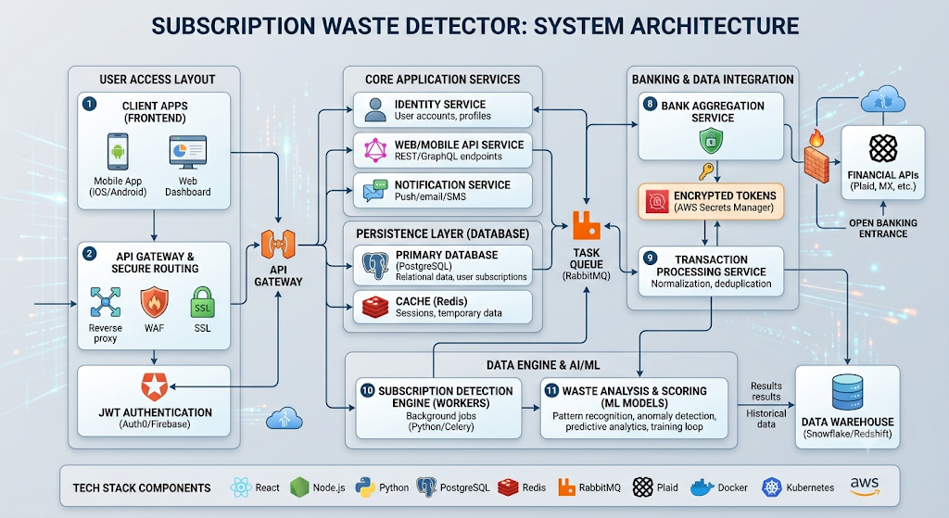

Explaining the Data Flow:
- User Requests Sync: The user clicks "Sync Banks" on their Mobile App.
- API GW Enqueues Request: The Edge API does not process this. It immediately drops a "Sync User X" task into the Redis Task Queue (Asynchronous Boundary). The user’s app receives a "Syncing..." status.
- Bank Service Executes: The specialized Bank Aggregation Service pulls the task, reads the secure Plaid token from Secrets Manager, and calls the Plaid API to fetch 2 years of transactions.
- Transactions Enqueued: The Bank Service receives thousands of transactions. It drops these "Raw Transactions" back into the Task Queue in batches.
- Detection Engine Processes: The Detection Worker (Python) pulls raw batches. It runs normalization (e.g., converting "PPD*NETFLIX" to "Netflix"), runs classification ML, identifies recurring patterns, and writes the results (the tagged subscriptions and waste score) into Postgres.
- Alerting: If the Detection Engine spots a high-waste item, it enqueues a "Send Alert" task, which the Notification Service picks up.
- Dashboard Refresh: When the user’s phone periodically polls the Edge API, the Edge API reads the finalized results from PostgreSQL/Redis and serves a fast, updated dashboard.

